SQUID Sensor

Abbas Saed Aljaghbeir **19290837**

Nurullah Mertel **18290219**

***Abstract*— For more than two decades Superconducting Quantum Interference Devices (SQUIDs) have played a key role in developing advanced measurement systems in the field of laboratory, bio-magnetic, industrial and geophysical applications due to their unparalleled sensitivity. The SQUID is an extremely sensitive sensor which gives measurable voltage output for an extremely small change of input magnetic flux. The SQUID sensor consists of two superconductors intersecting at a non-superconducting barrier known as Josephson junction.**

***Keywords—SQUID sensor, dc SQUIDs, rf SQUIDs, superconductors, Josephson junction.***

# INTRODUCTION

**SQUID** (**superconducting quantum interference devi- ce**) is the most sensitive magnetic detector known, it is basically used to measure extremely subtle magnetic fields, depending on a superconducting loop containing Josephson junctions. In Figure [1] below we can see a photo of a SQUID sensor. SQUIDs are sufficiently sensitive to measu- re extremely low magnetic fields like the magnetic field of heart or brain which are about $10^{-10}$ and $10^{-13},$ respectively. However the threshold of SQUIDs are surprisingly equals $10^{-15}.$ In the early 2000s, SERF atomic magnetometers are invented, which is more sensitive and do not require cryog- enic refrigeration(which is a sort of cooling done by liquidi- zed gasses) but are orders of magnitude larger in size (~1 cm3) and must be operated in a near-zero magnetic field.

Superconducting QUantum Interference Devices (SQUIDs) are the most sensitive detectors of magnetic flux currently available. They are amazingly versatile, being able to measure any physical quantity that can be converted to a flux, for example, magnetic field, magnetic field gradient, current, voltage, displacement and magnetic susceptibility. As a result, the applications of SQUIDs are wide ranging from the detection of tiny magnetic fields produced by the human brain.

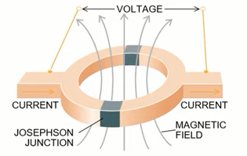

*Figure [1]: SQUID sensor (Superconducting Interference Device)*

# WORKING PRINCIPLES

## The SQUID sensor depends in its functions on 3 differe-

nt types of phenomena: superconductivity, Josephson effects and magnetic flux quantization.

## **Superconductivity**

## Superconductivity is a property related to a material when its resistance to the DC voltage becomes zero and the magnetic field is expelled from the material (Meissner effect). The property of superconductivity was discovered by Heike Kamerlingh Onnes in April 8,1911, when he found out that the resistance of mercury dramatically goes to zero below 4.2 K (-269°C). The material shows superconducting behavior when its resistance falls to be between absolute zero and 10 Kelvin, that is between -273 Celsius and -263 Celsisus.

The extraordinary behavior of superconductors has been explained by Bardeen–Cooper–Schrieffer theory or shortly known by BCS theory, this theory states that an electron moving through a conductor will attract nearby positive charges in the lattice. This deformation of the lattice causes another electron, with opposite spin, to move into the region of higher positive charge density. The two electrons then become correlated. Because there are a lot of such electron pairs in a superconductor, these pairs overlap very strongly and form a highly collective condensate. In this "condensed" state, the breaking of one pair will change the energy of the entire condensate - not just a single electron, or a single pair. Thus, the energy required to break any single pair is related to the energy required to break all of the pairs (or more than just two electrons).

Even though electrons normally exhibit repulsive behavior to each other, in superconductors this attraction is caused by a phonon exchange between two electrons. To illustrate it more, some electron in a superconductor is moving and emits some phonon and then changes its direction, this phonon is absorbed by an electron that has a different spin then it changes its direction as well. These pairs of electrons are known as Cooper pairs. In Figure [2] below we can see a diagram of the attraction in a Cooper pair.

The superconducting properties in each point of the superconductor are described by the complex quantum mechanical wave function Ψ(r,t) and it is just the wave function of cooper pairs as shown in the equation below:

$Ψ(r,t)=\left|Ψ\right|e^{iϕ}$ (1)

$\left|Ψ\right|$: the density of cooper pairs and also denoted by $η_{s}$

$ϕ$: the microscopic phase coherence

So that no matter how the size of the superconductor, the same wavefunction with the same amplitude and the same phase occupying the entire entity of the superconductor, this superconductor can be a little seed or even tons of superconductor material.

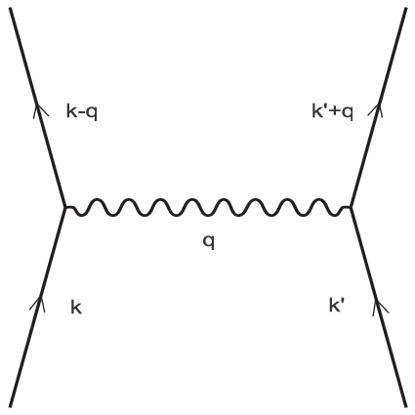

*Figure[2]: The attraction on Cooper pairs due to the phonon exchange.*

## **Josephson effect**

A Josephson effect consists of two superconductors separated by a thin insulating barrier. Cooper pairs of electrons are able to tunnel through the barrier maintaining phase coherence $ϕ$ in the process. The applied current, I controls the difference $δ=Φ_{1}-Φ_{2}$ between the phases of two superconductors according to the current phase relation

$I=I_{0} sin δ$ (2)

where $I_{0}$ is the critical current, that is the maximum current can sustain in the superconductor. When the current is increased from zero, initially there is no voltage across the junction but for $I>I_{0}$ a voltage V called by critical voltage appears, and $δ$ evolves with time according to the voltage frequency relation

$δ = 2eV/𝓀 =2πV$/ $ϕ_{0}$ (3)

where e and $𝓀$ are the electron charge and reduced Planck’s constant, respectively.

According to Jesephson effect, the macroscopic wave functions of two electrodes $Ψ_{1}=\left|Ψ_{1}\right|e^{iϕ_{1}}$ and $Ψ_{2 }=\left|Ψ_{2}\right|e^{iϕ_{2}}$ overlap in barrier region as shown in Figure 3 below.

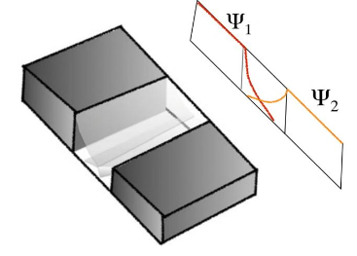

*Figure[3]: The overlapping of macroscopic wave functions at Josephson junction*

* 1. ***Flux quantization***

The contour or loop’s magnetic flux is represented by the symbol 𝝓 and it is retained by the dot product of the magnetic flux density B and the loop area S

*𝝓 = B . S (1)*

However, Once one handles a magnetic flux through a superconducting material, the magnetic flux is quantized in this case. The (superconducting) magnetic flux quantization $φ_{O}$ *≈2.067833848...×10−15 Wb* and obtained by the equation below:

$φ=h/2e$ (2)

h: Planck constant

e: Electron charge = 1.602176634×10−19 Coulomb

The phenomenon of flux quantization was discovered experimentally by B. S. Deaver and W. M. Fairbank and, independently, by R. Doll and M. Näbauer, in 1961

III. THE SQUID MAGNETOMETER

The SQUID Magnetometer can be used to detect very subtle magnetic fields to the order of even 5 aT (1 aT is $10^{-18}$ T). The SQUID Magnetometer was invented accidentally by a group of researchers at the Ford Motor Co. Scientific Research Laboratory in Dearborn in 1964(Johnson, 2014). The group consisted of John Lambe, James Zimmerman, Arnold Silver, Robert Jaklevic, and James Mercereau (from left in Figure [4]). But what was interesting and a little strange was that, at the time, the SQUID did not have much implications in the automotive industry.

**

*Figure[4]: The group of researchers from Ford Motors Co. who invented the SQUID*

1. **How the SQUID sensor works basically**

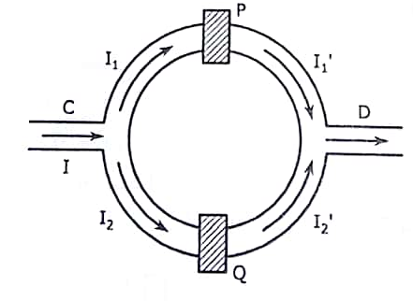

*Figure[5]: A schematic diagram of SQUID sensor.*

In Figure [5] above, we can see a schematic diagram of the SQUID sensor. Through the hole in the SQUID it is exposed to a magnetic field.However, a DC super current $I$ starts to flow in the device through port C, where the super current gets divided into two ports $I_{1}$ and $I_{2}$. Both these currents get phase-shifted while passing through the Josephson junctions P and Q and become ${I_{1}}^{'}$ and $I_{2}'$ respectively. The shifted super currents ${I_{1}}^{'}$ and $I_{2}'$ intersect at port D. In superconductors the current is caused by the Cooper pairs. So the interfering waves are the de Broglie waves of the Cooper pairs. The phase shifts of the waves occur due to the applied magnetic field. In the absence of the magnetic field the phase shift and the phase difference are zero. The resultant current at port D oscillates between maxima and minima. The maxima occurs when the magnetic flux increases by one quantum given by $ϕ_{0}=h/2e ≈ 2.06×10^{-15} Wb$.In practice instead of the current, the voltage V across the SQUID is measured. The voltage also oscillates with the changing magnetic field. Thus the SQUID is a flux-to-voltage transducer which converts a small change in magnetic flux into voltage. Because of their extreme sensitivity to magnetic fields, SQUIDS have application in many fields like geology, medicine, engineering, etc.

1. **Types of SQUID sensors**
2. **RF SQUID**

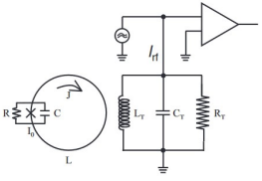

*Figure[6]: RF SQUID*

The rf SQUID consists of only a single Josephson Junction in a superconducting loop. For this reason, it is cheaper and easier when it is compared to the DC SQUID but also less sensitive than the DC SQUID. Also the rf SQUID (or Radio Frequency SQUID) could operate at much higher temperatures compared to the traditional 4K cooled superconductors and SQUIDs because the cryogenic cooling in this case was done in liquid hydrogen which was much more easily available(Clarke and Braginski, 2004). In figure[6] above, we can see a diagram of rF SQUID.

1. **DC SQUID**

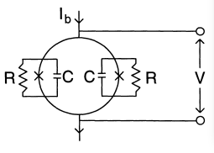

*Figure[7]: DC SQUID*

DC SQUID is the most sensitive magnetometer available, with an enormous signal bandwidth extending from dc to several GHz. In Figure [7] above we can see a schematic diagram of dc SQUID, two junctions are connected in parallel on a superconducting loop of inductance L. Each Josephson junction (represented by a cross) is shunted by an external resistor R in order to eliminate the hysteresis in the junction I-V characteristics, and C which is the intrinsic capacitance of each junction. I-V characteristics are shown in Figure [8] below for $ϕ=n{ ϕ}_{0}$ and $(n+1/2)ϕ_{0}$, where $ϕ$ is the external flux applied to the loop and n is an integer.

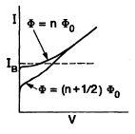

*Figure[8]: I-V characteristics for DC SQUID.*

In the absence of any applied flux or in ($ϕ=nϕ_{0})$, no current circulates around the loop and the bias current splits between the two junctions, the measured critical current is $2I_{0}$ (as the noise around the loop is neglected). If we apply a magnetic flux $ϕ,$ the flux in the loop will be quantized and will generate a current $J= -ϕ/L$. This current will circulate around the loop and will affect the critical current. As shown in figure [9] below, the circulating current adds to the bias current on one side $I_{0 }= I/2+J$ also subtracts from bias current on the other side $I_{0 }= I/2-J$. When $ϕ$ is increased to $ϕ_{0}/2$, J is increased to $ϕ_{0}/2L$.When $ϕ$ exceeds $ϕ_{0}/2$, J changes sign (as shown in Figure 10). As $ϕ$ is increased to $ϕ_{0}$, J is reduced to zero and now the critical current at its maximum $I_{m }=2I_{0}$ (as shown in Figure 11)

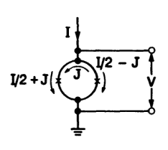

*Figure[9]: The effect of external flux on the super current*

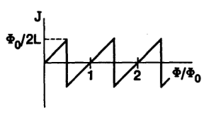

*Figure[10]: The relationship between the external magnetic flux $ϕ and$ the circulating current J*

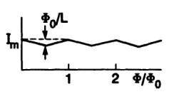

*Figure[11]: The relationship between the external magnetic flux $ϕ and$ the super current I*

IV. APPLICATIONS

The high sensitivity of SQUIDs makes them a perfect choice for studies in biology. [Magnetoencephalography](https://en.wikipedia.org/wiki/Magnetoencephalography) (MEG), for example, uses measurements from an array of SQUIDs to make inferences about [neural](https://en.wikipedia.org/wiki/Neuron) activity inside brains. Because SQUIDs can operate at acquisition rates much higher than the highest temporal frequency of interest in the signals emitted by the brain (kHz), MEG achieves good temporal resolution. Another area where SQUIDs are used is [magnetogastrography](https://en.wikipedia.org/wiki/Magnetogastrography), which is concerned with recording the weak magnetic fields of the stomach. A novel application of SQUIDs is the [magnetic marker monitoring](https://en.wikipedia.org/wiki/Magnetic_marker_monitoring) method, which is used to trace the path of orally applied drugs. In the clinical environment SQUIDs are used in [cardiology](https://en.wikipedia.org/wiki/Cardiology) for [magnetic field imaging](https://en.wikipedia.org/wiki/Magnetic_field_imaging) (MFI), which detects the magnetic field of the heart for diagnosis and risk stratification.

Probably the most common commercial use of SQUIDs is in magnetic property measurement systems (MPMS). These are [turn-key](https://en.wikipedia.org/wiki/Turnkey) systems, made by several manufacturers, that measure the magnetic properties of a material sample. This is typically done over a temperature range from that of 300 mK to roughly 400 K.[[20]](https://en.wikipedia.org/wiki/SQUID#cite_note-20) With the decreasing size of SQUID sensors since the last decade, such sensors can equip the tip of an [AFM](https://en.wikipedia.org/wiki/Atomic_force_microscopy) probe. Such device allows simultaneous measurement of roughness of the surface of a sample and the local magnetic flux.

For example, SQUIDs are being used as detectors to perform [magnetic resonance imaging](https://en.wikipedia.org/wiki/Magnetic_resonance_imaging) (MRI). While high-field MRI uses precession fields of one to several teslas, SQUID-detected MRI uses measurement fields that lie in the microtesla range. In a conventional MRI system, the signal scales as the square of the measurement frequency (and hence precession field): one power of frequency comes from the thermal polarization of the spins at ambient temperature, while the second power of field comes from the fact that the induced voltage in the pickup coil is proportional to the frequency of the precessing magnetization. In the case of untuned SQUID detection of prepolarized spins, however, the NMR signal strength is independent of precession field, allowing MRI signal detection in extremely weak fields, on the order of Earth's magnetic field. SQUID-detected MRI has advantages over high-field MRI systems, such as the low cost required to build such a system, and its compactness. The principle has been demonstrated by imaging human extremities, and its future application may include tumor screening.[[22]](https://en.wikipedia.org/wiki/SQUID#cite_note-22)

Another application is the [scanning SQUID microscope](https://en.wikipedia.org/wiki/Scanning_SQUID_microscope), which uses a SQUID immersed in liquid [helium](https://en.wikipedia.org/wiki/Helium) as the probe. The use of SQUIDs in [oil](https://en.wikipedia.org/wiki/Petroleum) [prospecting](https://en.wikipedia.org/wiki/Prospecting), [mineral exploration](https://en.wikipedia.org/wiki/Mineral_exploration),[[23]](https://en.wikipedia.org/wiki/SQUID#cite_note-23) earthquake prediction and [geothermal energy](https://en.wikipedia.org/wiki/Geothermal_energy) surveying is becoming more widespread as superconductor technology develops; they are also used as precision movement sensors in a variety of scientific applications, such as the detection of [gravitational waves](https://en.wikipedia.org/wiki/Gravitational_wave).[[24]](https://en.wikipedia.org/wiki/SQUID#cite_note-24) A SQUID is the sensor in each of the four gyroscopes employed on [Gravity Probe B](https://en.wikipedia.org/wiki/Gravity_Probe_B) in order to test the limits of the theory of [general relativity](https://en.wikipedia.org/wiki/General_relativity).[[1]](https://en.wikipedia.org/wiki/SQUID#cite_note-Ran04-1)

A modified RF SQUID was used to observe the [dynamical Casimir effect](https://en.wikipedia.org/wiki/Dynamical_Casimir_Effect) for the first time.[[25]](https://en.wikipedia.org/wiki/SQUID#cite_note-25)[[26]](https://en.wikipedia.org/wiki/SQUID#cite_note-26)

SQUIDs constructed from super-cooled [niobium](https://en.wikipedia.org/wiki/Niobium) wire loops are used as the basis for [D-Wave Systems](https://en.wikipedia.org/wiki/D-Wave_Systems) 2000Q [quantum computer](https://en.wikipedia.org/wiki/Quantum_computer).

V. ACKNOWLEDGMENTS

It was such a great opportunity to learn about superconductivity and the related phenomena to it like Cooper pairs, Josephson effect and flux quantization.

SQUIDs are such impressive devices as they undergo quantum mechanics which is only applied on infinitesimal components like electrons and bosons. In addition, the extraordinary sensitivity of SQUIDs makes them versatile and applicable for aspects where the magnetic field is hardly detectable like biology.

VI. REFERENCES

[1] SQUID Magnetometer -A Study, by Parnav SA

[Pranav S A | Currently pursuing Integrated BS-MS Degree | Indian Association for the Cultivation of Science, Kolkata | Research profile (researchgate.net)](https://www.researchgate.net/profile/Pranav-S-A)

[2] SQUID Sensors: Fundamentals, Fabrication and Application

[3] Fundamentals and Frontiers of the Josephson Effect, edited by Francesco Tafur**i‏**

[4] [SQUID - Wikipedia](https://en.wikipedia.org/wiki/SQUID)

[5] [SQUID Magnetometer and Josephson Junctions (gsu.edu)](http://hyperphysics.phy-astr.gsu.edu/hbase/Solids/Squid.html)

[6][Quantum Transport, Lecture 13: Superconductivity](https://youtu.be/dT6-iyz3DNY)

https://youtu.be/dT6-iyz3DNY